**TO WHOMSOEVER IT MAY CONCERN**

**DATE: 25-March-2021**

From,

**Mr Rajesh Punabaka (DHL IT Services)**

No.: 5-2051/1, Ashokpuram,

Chittoor-517001, Andhra Pradesh.

**Landmark:** CK Babu Party Office

Mobile #: 9884972710.

To,  
**Kumaaresan S**

DHL Information Services (India) LLP,

Chennai One, IT-SEZ, 10th floor (Module 7 &8),

Pallavaram – Thoraipakkam 200 Ft road,

Thoraipakkam, Chennai – 600097.

Mobile:  + 91 8754434252

**We hereby declaring that we are sending the below mentioned item for our internal purpose.**

**Approx Value mentioned below.**

|  |  |  |  |  |  |
| --- | --- | --- | --- | --- | --- |
| **Sl.No** | **Make** | **Model** | **Quantity** | **Value** | **Remark** |
| 1 | HP | HP EliteBook 840 G5 | 1 | 40000/- |  |

For DHL IT Services

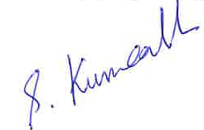

Kumaaresan S